Project ID: J26-ISE-313
1. Topic (12 words max)
A Smart Consulting Platform for Sri Lankan Technology Product Success
- Research group the project belongs to
TIM-Technology Integration and Management
- Specialization of the project belongs to
Information System Engineering (ISE)
- If a continuation of a previous project
Project ID | J26-ISE-313
Year | 2026
- Brief description of the research problem including references (300 words max) – references not included in word count.
Sri Lankan technology companies develop many useful and technically advanced products. However, some of these products fail after development or launch. In many cases, the main reason is not poor software quality. The failure happens because companies do not properly study the market, understand their users, check legal requirements, plan their marketing, or prepare the required infrastructure.
This problem affects startup founders, entrepreneurs, product managers and business leaders. It also affects companies that have already launched a product but are struggling to gain users or improve performance.
The research focuses on four main bottlenecks.
The first bottleneck is marketing. Companies may use technical language when communicating with non-technical customers, copy competitor messages or choose unsuitable marketing channels.
The second bottleneck is government rules and regulations. Some companies begin development without checking data protection, licensing, taxation or sector-related requirements. Legal problems may only be discovered after money and time have already been spent.
The third bottleneck is product and service management. Companies may build products based on assumptions instead of real user needs. They may also develop features that users do not want or that the local market is not ready to use.
The fourth bottleneck is infrastructure. Companies may underestimate their internet, server, hardware, office and scalability requirements.
These issues can lead to wasted development costs, legal risks, poor user adoption, launch delays and product shutdowns. Therefore, this research proposes a Sri Lanka-specific consulting framework and digital platform that addresses all four areas before and during product development.
6. Brief description of Existing Research and Systems (300 words max)
Existing research and systems address each of the four bottlenecks separately, but not together in a Sri Lanka-specific way.
For marketing, Madurapperuma and Colombage (2022) used the Technology-OrganisationEnvironment framework to study why Sri Lankan SMEs adopt or avoid digital marketing, and found limited digital literacy, cost and lack of technical skill as major barriers; their study measures adoption but does not offer a tool that classifies audiences or recommends channels.
For government rules and regulations, Sri Lanka's Personal Data Protection Act No. 9 of 2022 created the Data Protection Authority and set clear obligations for lawful data processing (Data Protection Authority of Sri Lanka, n.d.), but compliance guidance exists only as legal text and generic checklists, not as a system that connects a specific product idea to the rules that apply to it.
For product and service management, Ries's (2011) Lean Startup methodology and
Osterwalder and Pigneur's (2010) Business Model Canvas, later adapted into the Lean Canvas
(Maurya, 2012) and Value Proposition Canvas (Osterwalder, Pigneur, Bernarda, & Smith, 2014), are widely used tools for validating product ideas, but they are generic templates a founder fills in manually rather than software that scores features against local market data.
For infrastructure, the AWS Well-Architected Framework (Amazon Web Services, n.d.) gives companies a structured way to review cloud architecture against six pillars, but it assumes the company already has a cloud deployment and does not help a Sri Lankan startup choose an ISP, decide on a virtual office, or plan early scaling.
Locally, Wimal and Ajendra (2023) and Gankandage and Jayathilaka (2025) confirm Sri Lankan technology start-ups fail from a mix of these same causes, but neither proposes a system. No existing research or tool combines all four areas into one Sri Lanka-specific platform, which is the gap this research addresses.
References
Amazon Web Services. (n.d.). AWS Well-Architected Framework. Retrieved July 2026, from https://aws.amazon.com/architecture/well-architected/
Data Protection Authority of Sri Lanka. (n.d.). About the Authority. Retrieved July 2026, from https://www.dpa.gov.lk/
Gankandage, A., & Jayathilaka, R. (2025). Unveiling the challenges: Exploring start-up hurdles faced by small and medium-sized enterprise entrepreneurs in Sri Lanka. Humanities and Social Sciences Communications, 12(1).
Madurapperuma, R. K., & Colombage, V. K. (2022). Factors affecting the adoption of digital marketing by SMEs in the context of Sri Lanka. Proceedings of the International Conference on Business and Information (ICOBI).
Maurya, A. (2012). Running Lean: Iterate from Plan A to a Plan That Works (2nd ed.). O'Reilly Media.
Osterwalder, A., & Pigneur, Y. (2010). Business Model Generation: A Handbook for Visionaries, Game Changers, and Challengers. Wiley.
Osterwalder, A., Pigneur, Y., Bernarda, G., & Smith, A. (2014). Value Proposition Design: How to Create Products and Services Customers Want. Wiley.
Ries, E. (2011). The Lean Startup: How Today's Entrepreneurs Use Continuous Innovation to Create Radically Successful Businesses. Crown Business.
Wimal, K., & Ajendra, S. (2023). A phenomenological exploration of technology start-up failure in Sri Lanka. Journal of Entrepreneurship, Management and Innovation, 19(3), 45\u201372.
- Brief description of the solution’s nature, including a conceptual diagram (maximum 500 words).
The proposed solution is a digital consulting platform for Sri Lankan technology companies. Its main purpose is to reduce avoidable product and service failures by helping companies make better decisions before development, during development and when preparing for launch.
Users of the system
The platform can be used by:
- Startups planning to build a new product.
- Companies whose products failed or did not gain enough users.
- Companies improving an existing product.
- Established companies planning to introduce a new product or service.
Inputs
The company will provide information such as:
- Product or service idea.
- Current business stage.
- Proposed features.
- Target users.

- Industry sector.
- Budget and team size.
- Competitor details.
- Types of data collected from users.
- Marketing plans.
- Current or planned infrastructure.
- Expected number of users and future growth.
The system may also collect information through user questionnaires, interviews, local market data, regulatory documents and infrastructure-provider information.
Processing through the four components
Component 1: Marketing
This component checks whether the target audience is technical or non-technical. It helps the company explain the product in language that the customer can understand. It also studies competitor messages and recommends suitable marketing channels based on the product, audience and budget.
Component 2: Government Rules and Regulations
This component connects the product idea and proposed features with relevant Sri Lankan legal and regulatory requirements. It identifies possible compliance risks before development and provides sector-based guidance for areas such as fintech, healthtech, edtech and ecommerce.
Component 3: Product Performance Assessment Tool
This component checks whether the product solves a real user problem. It collects user expectations, identifies local market barriers, generates a SWOT analysis and scores proposed features according to market need and user readiness.
Component 4: Infrastructure Assessment
This component checks whether the company has suitable internet, servers, hardware, power arrangements and office facilities. This component evaluates whether a company has adequate internet connectivity, servers, hardware, power arrangements, and office facilities in place. It also supports infrastructure planning for future growth.
Final output
The platform will provide a combine d launch-readiness report containing:
- Marketing and communication guidance.
- Competitor-positioning opportunities.
- Recommended marketing channels.
- A compliance-risk report.
- Industry-specific legal guidance.
- A SWOT analysis.
- User-expectation findings.

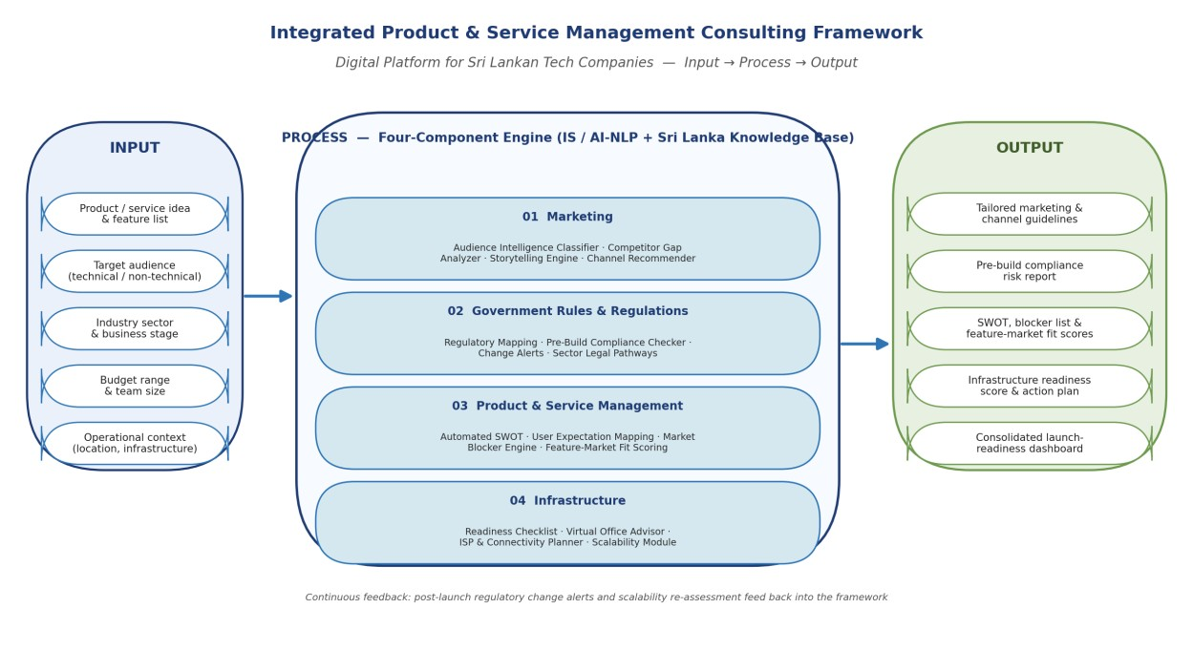
•

Market blockers.

•

Feature
-
market fit scores.

•

An infrastructure
-
readiness score.

•

A prioritised action plan.

The four component results will be shown through one dashboard. This will help the
company understand what should be corrected before spending more money on development
or launching the product.

- Brief overview of the availability of necessary specialized domain expertise, knowledge, and data. (500 words max)
The project requires knowledge in marketing, Sri Lankan regulations, product management, infrastructure planning and information systems development.
Each team member will be responsible for one component. The member will study the selected area through research papers, industry reports, existing systems and discussions with professionals.
For the marketing component, the team will consult startup founders, product managers and digital-marketing professionals. Their knowledge will help the team understand audience behaviour, communication problems, competitor positioning and commonly used Sri Lankan marketing channels.
For the government rules and regulations component, the team will study official regulatory documents and consult legal or compliance professionals. This is required to correctly

understand areas such as data protection, taxation, licensing, telecommunications and sectorbased requirements.
For the product and service management component, the team will work with product managers, founders and potential end users. Product-management methods such as Lean Startup, Design Thinking and Jobs-to-be-Done will be studied and adapted to the Sri Lankan context.
For the infrastructure component, the team will consult DevOps engineers, cloud professionals, internet-service providers and technology companies. Provider plans, service agreements, scalability requirements and common infrastructure problems will also be studied.
Primary data will be collected using surveys, semi-structured interviews and user questionnaires. Participants may include founders, entrepreneurs, product managers, marketers, legal professionals, infrastructure professionals and potential product users.
Secondary data will include research papers, case studies, market reports, official legal documents, government publications and infrastructure-provider information.
The technical implementation may include full-stack web development, databases, rule-based systems, natural-language processing, recommendation methods and scoring models. Rulebased methods can be used where reliable machine-learning data is not available.
Ethical approval will be obtained before collecting information from participants.
Participation will be voluntary, consent will be collected, responses will be anonymised and research data will be stored securely.

- Objectives and Novelty
Main Objective
To design, develop and validate a smart consulting platform that supports the success of Sri Lankan technology products by guiding companies in marketing, government rules and regulations, product and service management, and infrastructure planning, thereby reducing avoidable product and service failures.
Member Name with Registration No | Sub Objective | Tasks | Novelty

Hapugodaarachchi H.A.K.K.  [Reg. No. – IT23135284] | To build an AI tool for Sri Lankan tech companies that simplifies technical marketing messages and recommends the best channels and budgets. | 1.Conduct Survey and interview local startup founders and marketers.  2.Design forms to collect raw product descriptions, target demographics, marketing budget (in LKR), conversion goals, and target regions.  3.Develop the Audience Intelligence Classifier using NLP to analyze product text, extract domain keywords, and calculate a Technical Literacy Score.  4.Develop the Automated Feature-to-Value Translator to convert technical product jargon into simple customer value statements.  5.Build a knowledge base of Sri Lankan digital market metrics.  6.Build a channel ranker that uses the AHP algorithm to select the best marketing platforms.  7.Implement the Budget Allocation Engine to automatically distribute monthly budgets across ranked channels.  8.Generate a complete summary report with audience profiles and charts. | Novelty 1: Audience Technical Literacy Classifier  Analyzes the product description using text processing to identify whether the target audience is technical or non-technical, and determines the most suitable communication style.  Novelty 2: Smart Channel & Budget Recommendation System  Recommends suitable marketing platforms according to product type, audience, budget, and Sri Lankan digital behavior, and automatically optimizes monthly budget allocation.  Component Output  - Integrated Sri Lankan Marketing Strategy Dashboard and Report

Singappuli  [S. M. T. N]  [Reg. No. – IT23135284] | To help Sri Lankan technology companies assess their infrastructure and plan for internet, servers, hardware, office space, and future growth. | - Examine infrastructure challenges typically encountered by Sri Lankan technology companies.  - Conduct surveys with companies regarding issues related to internet access, hosting, servers, hardware, and office space.  - Gather data on local ISPs, cloud service platforms, and available infrastructure options.  - Establish criteria for assessing infrastructure readiness.  - Create data-collection forms covering company size, budget, product category, and anticipated growth.  - Build the Infrastructure Readiness Checklist.  - Build the Scalability Planning Module.  - Generate an infrastructure-readiness summary with a prioritised action plan.  - Validate the proposed recommendations with participating companies and infrastructure specialists. | Novelty 1: Automated Infrastructure Readiness and Scalability Advisor  The proposed solution automatically analyses a company's infrastructure-related responses and generates a customised infrastructure readiness and growth plan.  The output includes:  - An infrastructure readiness score covering internet connectivity, servers, power arrangements, hardware, and office facilities.  - A scalability plan based on expected user growth, team expansion, bandwidth needs, and budget.  The main novelty is combining infrastructure-readiness assessment and scalability planning into one solution, helping companies identify infrastructure gaps and prepare for future growth before or during product development.

Pathirage [A.S.N.R]  [Reg. No. – IT23191938] | To develop a product and service management solution that collects questionnaire responses, analyses product or service ideas, and generates useful reports. The solution will help companies validate ideas, improve their products or services, attract and retain customers, and increase customer satisfaction. | - Review existing product validation, SWOT analysis, and market research methods.  - Design questionnaires for planned products, underperforming products, and products that need improvement.  - Develop a system to analyse the questionnaire responses using RAG architecture.  - Generate an automated SWOT analysis based on the collected information.  - Generate a market research guide and a potential market blockers report.  - Test the solution with selected users or companies and improve it based on their feedback. | Novelty 1: Automated Product and Service Validation Report Generator  The proposed solution automatically analyses questionnaire responses and generates a customised validation report for a product or service idea.  The report includes:  A SWOT analysis identifying strengths, weaknesses, opportunities, and threats.  A market research guide explaining what information the company should investigate.  A potential market blockers report identifying issues that may affect product or service success.  The main novelty is combining these three reports into one solution, helping companies make better decisions before developing or improving a product or service.

Wijesooriya M G D R  [Reg. No. – IT23317376] | Build a tool that helps Sri Lankan tech companies easily find and follow legal, tax, and data laws before and after launching products. | - Review Sri Lankan laws and regulations related to technology products  - Interview legal, compliance and industry professionals  - Collect and organise relevant regulatory information  - Develop the Sri Lanka Regulatory Mapping Module.  - Develop the Pre-Build Compliance Checker. | Novelty :  Novelty 1: Sri Lanka Regulatory Mapping Module  Provides a searchable collection of Sri Lankan regulations that may affect technology products, with simple explanations.  Novelty 2: Pre-Build Compliance Checker  Checks a product idea and proposed features for possible legal or compliance risks before development begins.  Component output  - Pre-build compliance-risk report. .  - Required licences or approvals.  - Data-protection guidance.  - Tax and operational considerations.

- This section is to be completed by the Supervisor and the Co-supervisor of the Project.
- This research topic possesses a comprehensive scope suitable for a final-year project.
Yes |  | No
- The proposed topic exhibits novelty.
Yes |  | No
- The student group can successfully execute the proposed project.
Yes |  | No
- The proposed sub-objectives reflect the students’ areas of specialization.
Yes |  | No
- Data required for the project is available.
Yes |  | No
- Any other comments:

 | Title | First Name | Last Name | Signature
Supervisor*
Co-Supervisor*
External Supervisor
Summary of external supervisor’s (if any) experience and expertise

* At this stage, identifying the Co-Supervisor is compulsory. Students should reach out to a staff member, with guidance from their supervisor, to serve as the co-supervisor for this project.
V2.2 updated on 04th June 2026 Page 16 of 16

